Rainfall Prediction: Accuracy Enhancement Using Machine Learning and Forecasting Techniques

India’s revenue heavily dependent on agriculture and agricultural growth is heavily dependent on Rain/Precipitation so its mandatory to effectively predict the quantity of rainfall in future time so farmers can plan sowing and other agricultural works based on that prediction. So author of this paper evaluating the performance of various machine learning algorithms such as SVM, ARIMA, Neural Networks and many more to predict/forecast rainfall and then enhancing accuracy of best performing model.

In all algorithms Random Forest and Decision Tree is giving better performance and we are using below dataset to train all the algorithms

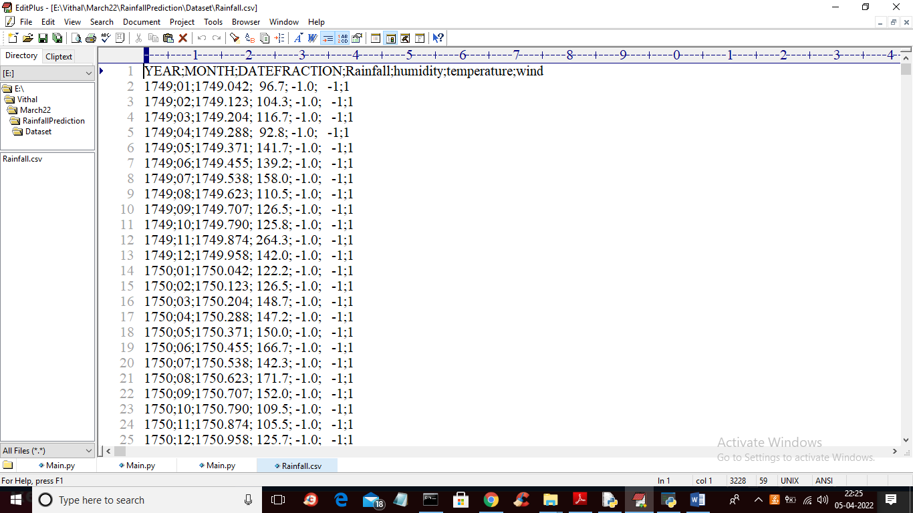

In above screen first row represents column names of the dataset and remaining are the dataset values.

To implement this project we have designed following Modules

1. Upload Rainfall Dataset: using this module we will upload dataset to application
2. Preprocess Dataset: using this module we will read all dataset values and then replace missing values with 0 and then normalized the dataset and then split dataset into train and test values
3. Run SVM Algorithm: using this module we will input processed train values to SVM algorithm to trained a model and this model will be applied on test data to perform prediction and then calculate accuracy and RMSE on predicted values
4. Run Random Forest Algorithm: using this module we will input processed train values to Random Forest algorithm to trained a model and this model will be applied on test data to perform prediction and then calculate accuracy and RMSE on predicted values
5. Run Decision Tree Algorithm: using this module we will input processed train values to Decision Tree algorithm to trained a model and this model will be applied on test data to perform prediction and then calculate accuracy and RMSE on predicted values
6. Run Neural Network Algorithm: using this module we will input processed train values to Neural Networks algorithm to trained a model and this model will be applied on test data to perform prediction and then calculate accuracy and RMSE on predicted values
7. Run KNN Algorithm: using this module we will input processed train values to KNN algorithm to trained a model and this model will be applied on test data to perform prediction and then calculate accuracy and RMSE on predicted values
8. Accuracy Graph: using this module we will plot accuracy and RMSE values of each algorithm for comparison

SCREEN SHOTS

To run project double click on ‘run.bat’ file to get below screen

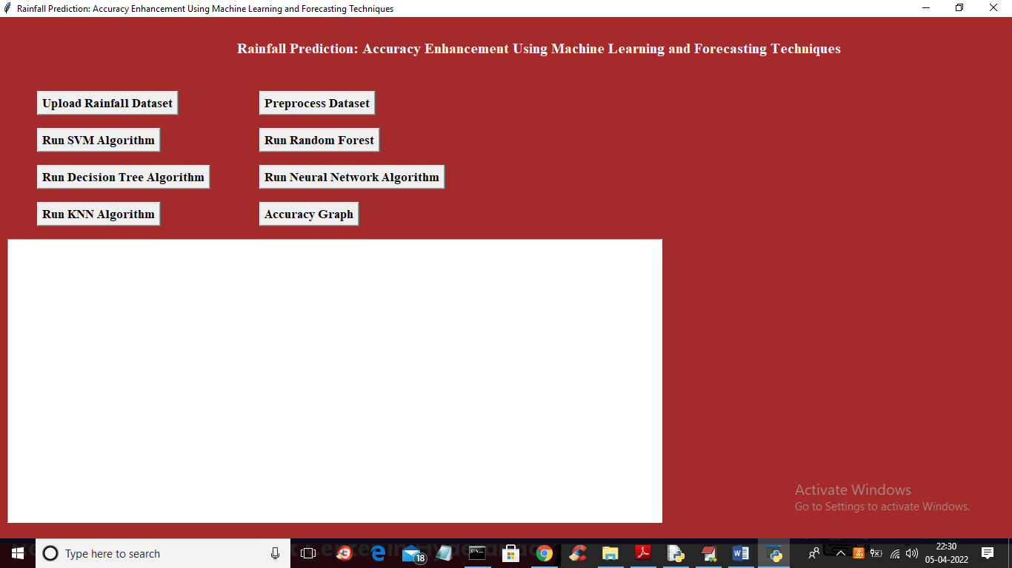

In above screen click on ‘Upload Rainfall Dataset’ button to upload dataset to application and get below output

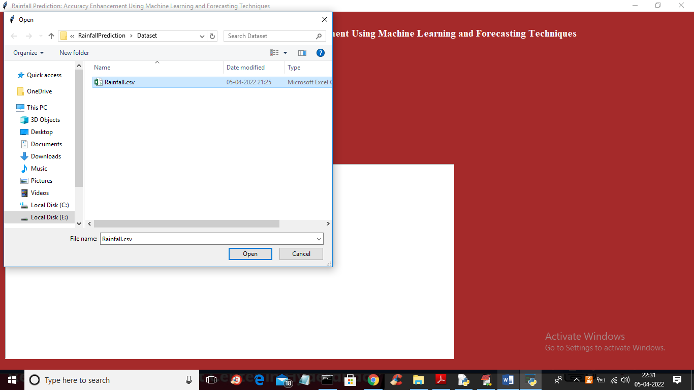

In above screen selecting and uploading ‘Rainfall.csv’ file and then click on ‘Open’ button to load dataset and to get below output

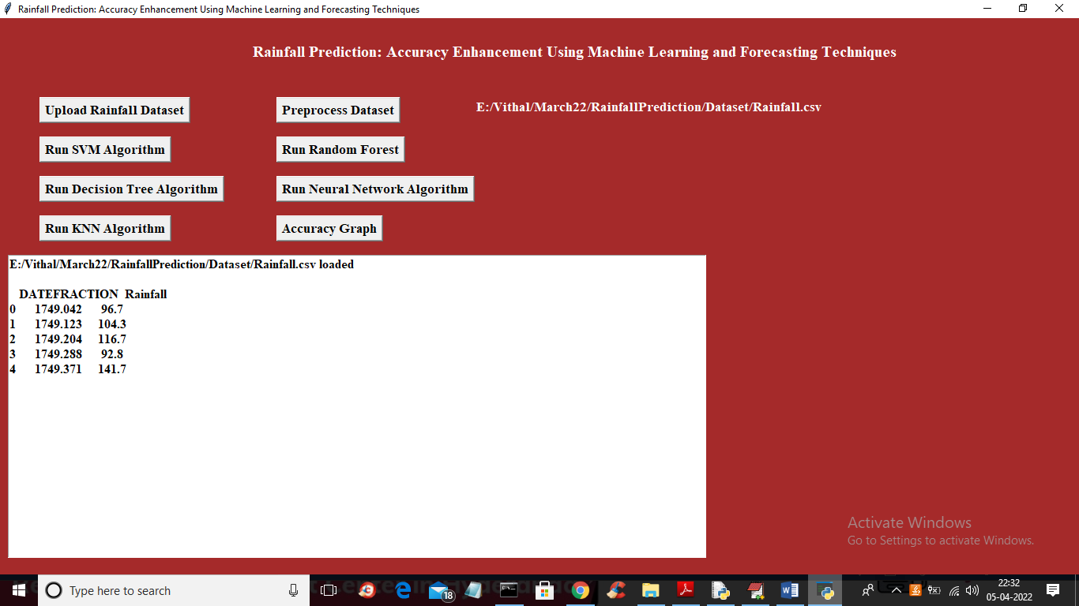

In above screen dataset loaded and now click on ‘Preprocess Dataset’ button to read, normalize and split dataset into train and test

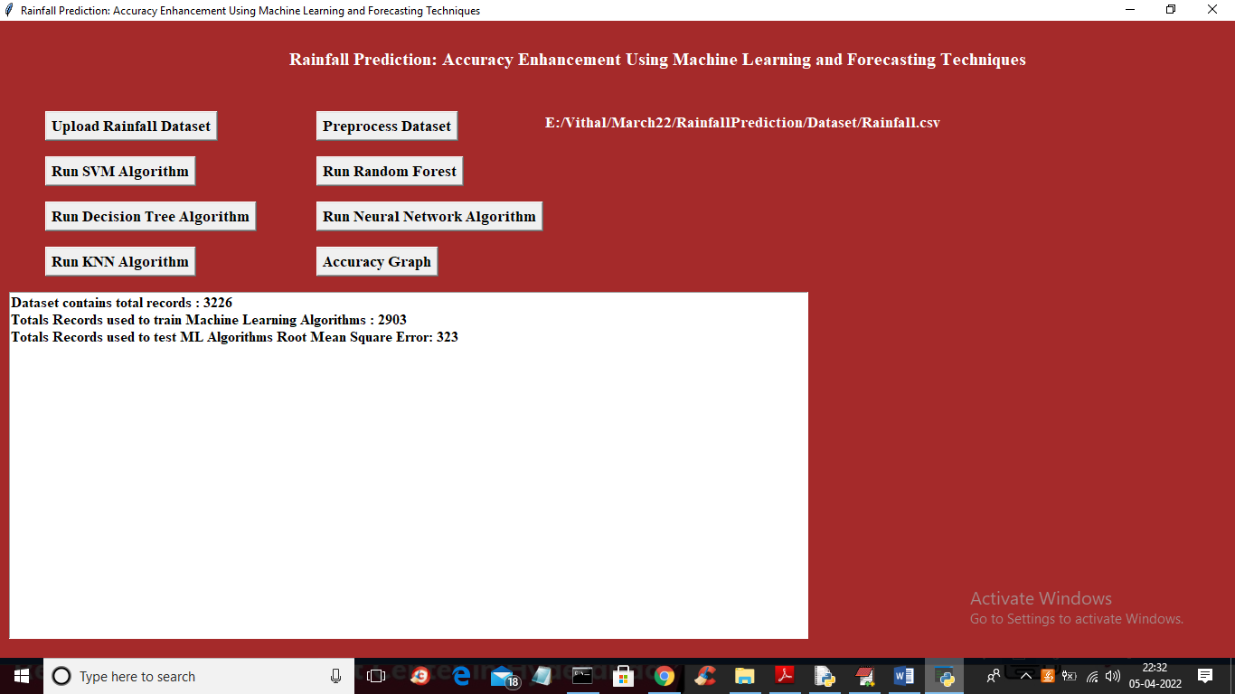

In above screen we can see dataset contains 3226 records and application using 80% (2903) records for training and 20% (323) records for testing and now dataset is ready and now click on ‘Train SVM Algorithm’ button to train SVM and get below prediction output

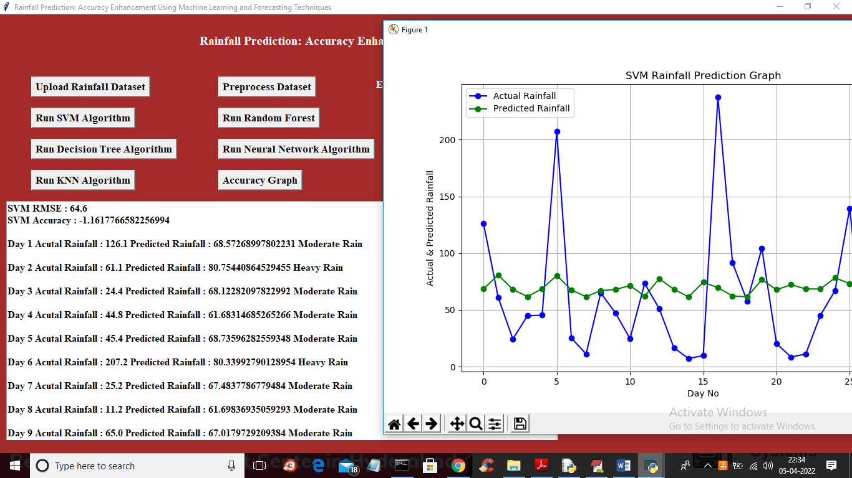

In above screen in first 2 lines displaying SVM accuracy and RMSE values and then displaying 30 days rain prediction as heavy or etc and in graph x-axis represents DAYS and y-axis represents predicted rainfall and blue line represents test rainfall data and green line represents predicted rainfall and we can see there is huge difference in blue and green line so SVM is not giving better prediction and now close above graph and then click on ‘Run Random Forest’ button to train Random Forest and get below output

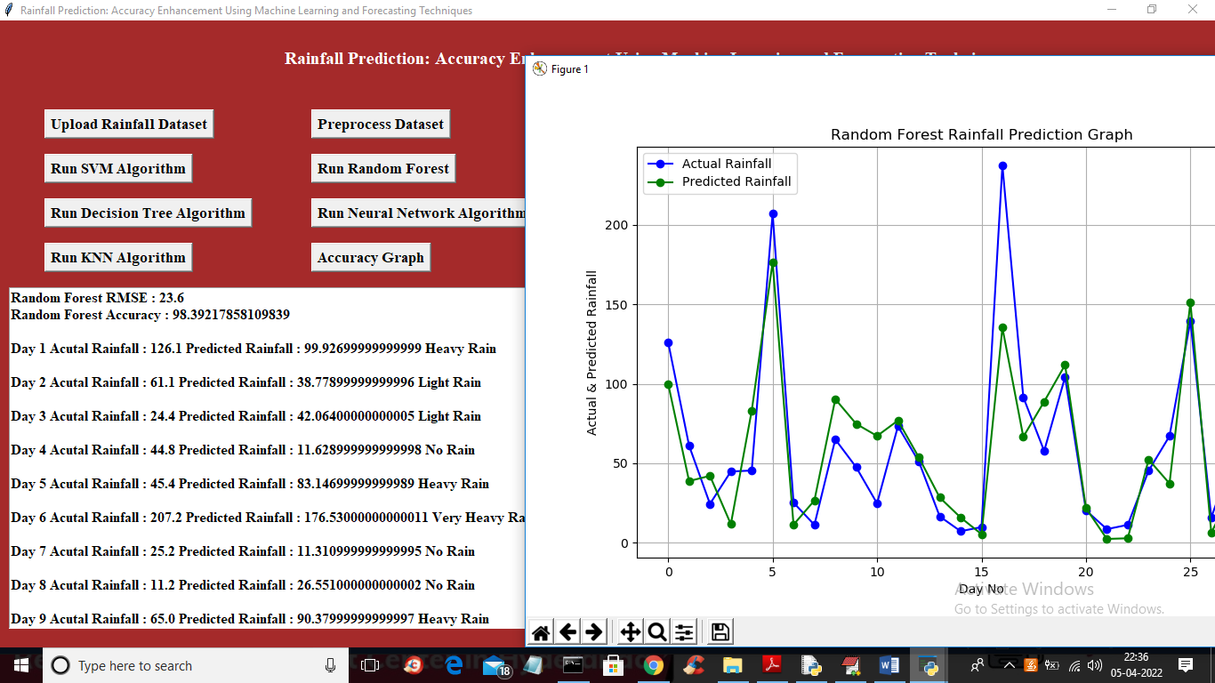

In above screen with Random Forest we got 98% accuracy and in graph both lines are overlapping so test values and predicted values are accurate and random forest performance is good and now close above graph and then click on ‘Run Decision Tree’ button to train decision tree and get below output

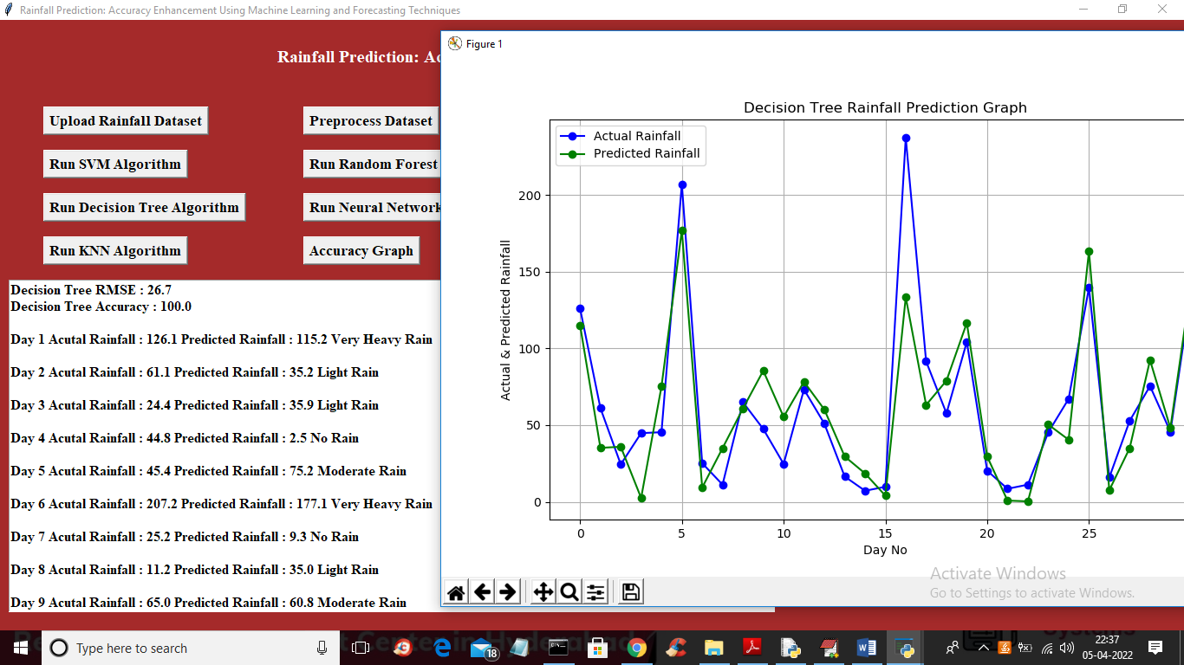

In above screen with Random forest we got 100% accuracy and in graph both lines are overlapping so decision tree performance also good and now close above graph and then click on ‘Run Neural Network’ button to get below output

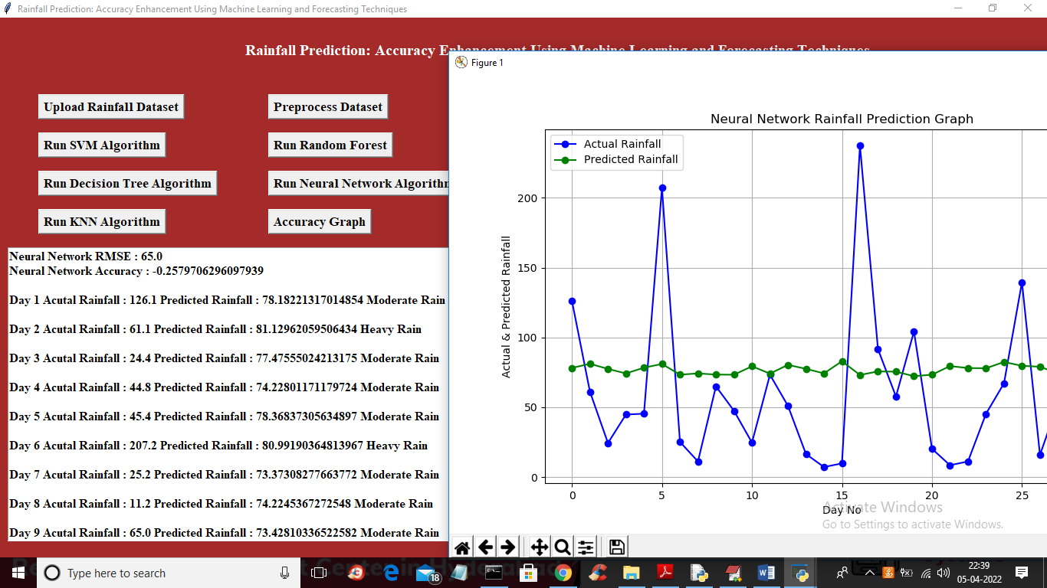

In above screen we can see Neural Network performance also not good and now click on ‘Run KNN Algorithm’ button to get below output

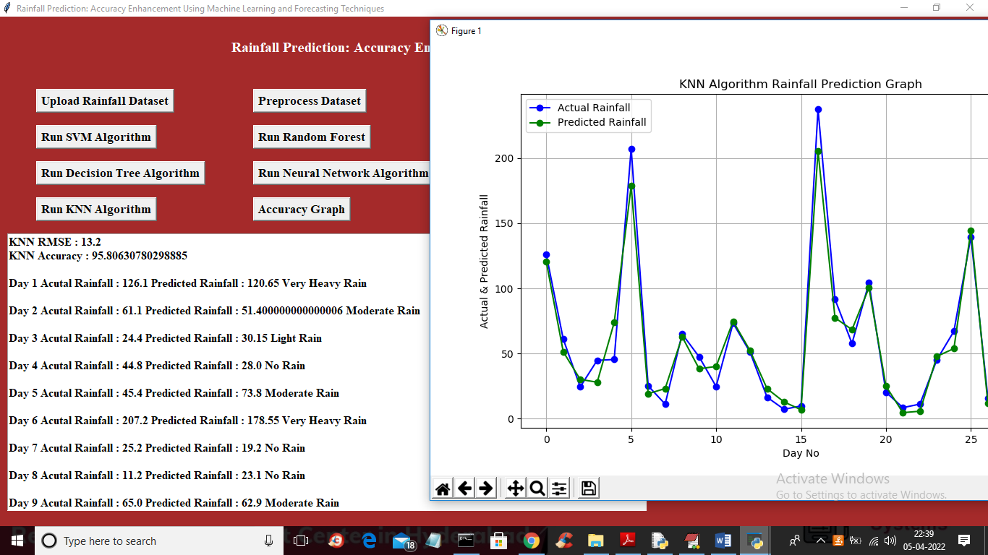

In above screen with KNN we got 95% accuracy and both lines are overlapping so KNN performance is also good and now click on ‘Accuracy Graph’ button to get below graph

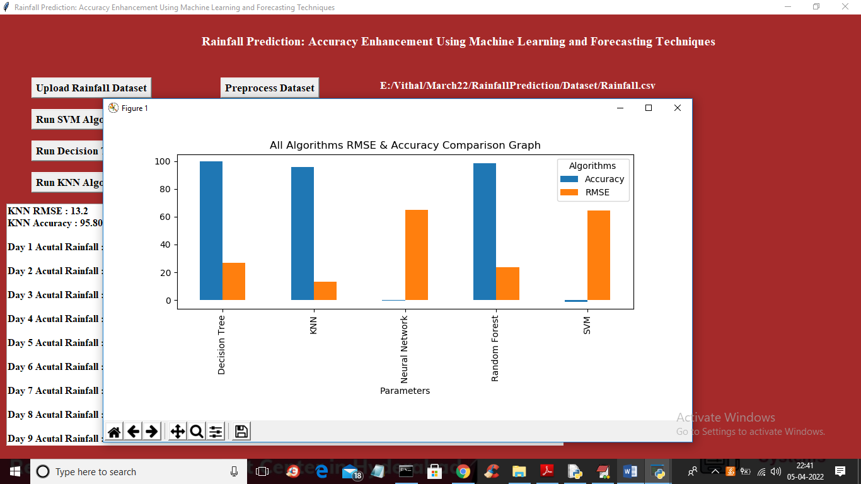

In above graph x-axis represents algorithm name and y-axis represents accuracy and RMSE values and blue bar indicates accuracy and orange bar indicates RMSE and in all algorithms Decision Tree and Random Forest gave high accuracy and outperform other algorithms